Marketers understand the need for measuring the estimated reach across their marketing campaigns to help them better optimizes their marketing decisions.
Calculating the reach of online media (yha pe digital calculator ki link) is easy, on the other side, calculating the reach for offline media is as tricky yet equally necessary. It takes a lot of factors and insights to fully understand the reach of the offline media to launch effectively successful marketing campaigns.
Whether its radio, TV, print or outdoor, or even digital, the lack of specific data and insights might lead your marketing efforts to hit the bottom line and jeopardize your allover marketing budget.
Fortunately, there’s a way through which you can get the estimated reach of your offline and online marketing campaigns to help you make better marketing decisions.
Yes you’ve read it right; we can help you estimate the reach of your offline and online marketing campaigns to help you optimize your efforts and marketing budget.
TMA’s Reach Calculator Tool
TMA’s Reach Calculator is a simple tool (Excel) in which you can calculate the reach of the following advertising mediums according to your requirement:
- Radio
- Television
- Cinema
- Newspaper
- Magazine
- Airport
- Aircraft
- Digital Media
Who is it for?
TMA’s Reach Calculator is for all the marketers and advertisers who want to calculate the estimated reach of their marketing campaigns on different offline and online advertising mediums.
How will TMA’s Reach Calculator Tool help you?
- Once you open the sheet, you can choose your preferred advertising medium to calculate the estimated reach.
- You can optimize the result by applying the available filters on your preferred media.
- You can also get the overall estimated reach of your marketing campaign by choosing the multiple mediums at the same time.
TMA’s Reach Calculator Tool was developed by the years of practice and experience in the media industry. We have used the standard formulas and different variable values for the individual mediums to calculate the best accurate results.
How to use TMA’s Reach Calculator Tool?
The Reach Calculator Tool is a downloadable sheet while you will be able to access in Microsoft Excel.
This is how the sheet will appear when you download and open the sheet in the software. (Click on the link to download the tool)
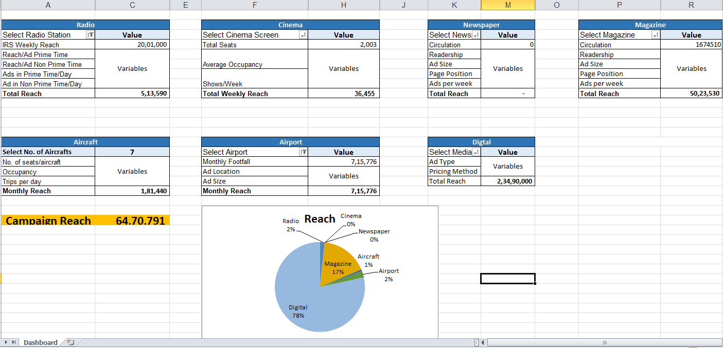

Now, let me quickly breakdown each of advertising mediums and the key metrics that you will be interacting with and the results will be changed accordingly.
- Radio
Radio is one of the most effective and innovative offline media to grab the attention of mass audience. The variables that directly affect the reach of a radio campaign are:
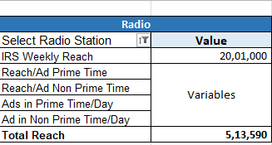
- IRS Weekly Reach
- Time band (Prime time/ Non-prime time)
- Ads in the time band/day
When you select the filter option in the top right corner of the radio table, you will see a list of radio channels to select.
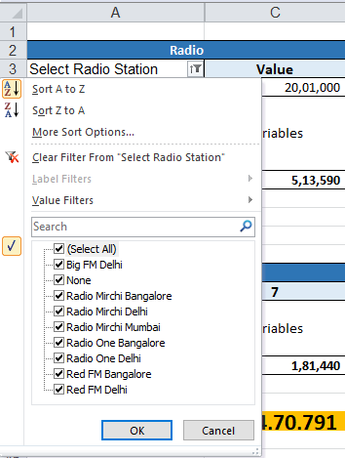

Select your preferred radio channel [s] to calculate the reach of your marketing campaign.
- Cinema- Cinema advertising is one of the most effective medium for hyper-local advertising. The key factors which affects the reach of cinema advertising campaigns are-
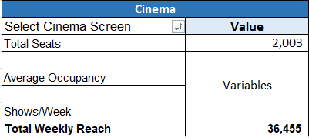
- Cinema Screen Type
- Total seats
- Average occupancy of the cinema hall
- Show/week
Select your screen type [s] according to the location from the top right filter icon of the cinema table to calculate the reach of your chosen cinema screen.
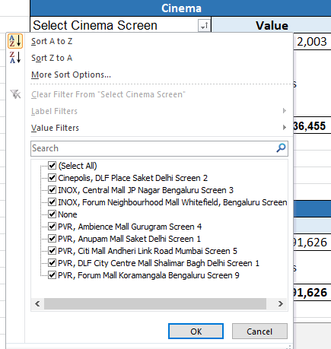
- Newspaper- Newspaper advertising is the best option to get access to individual homes and apartments and make a statement. The key factors which defines the reach of a particular newspaper are:
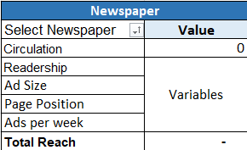

- Circulation of the newspaper
- Readership of the newspaper
- Ad Size
- Page Position
- Ads per Week
Select your preferred newspaper [s] according to the location from the filter option to calculate the estimated reach of your selected newspaper [s]
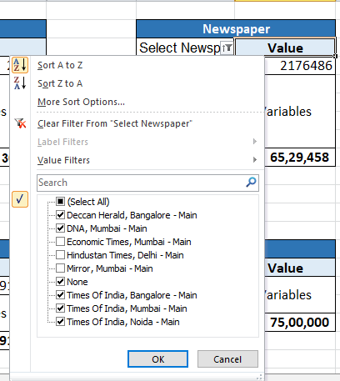

- Magazine- Magazine Advertising is the best way to target the niche audience. The variables to measure the reach of a magazine are:

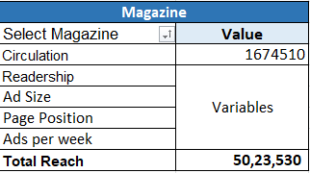

- Circulation of the magazine
- Readership of the magazine
- Ad Size
- Page Position
- Ads per week.
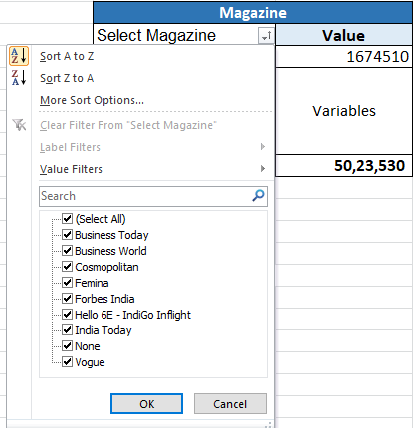
Select your preferred magazine [s] from the top right filter option in the magazine table to get the reach of your chosen magazine.
- Aircraft- Advertising on Aircraft is one of the most popular sources of targeting premium audience at a higher engagement rate. The factors that affects the reach of an Aircraft advertising are:
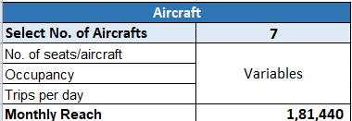

- No of seats and the aircraft
- Occupancy
- Trips per day
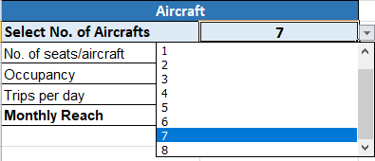
Select your required number of aircrafts from the table, and get the estimated monthly reach.
- Airport- Airport is the entry and exit point of any city, and is one of the most preferred medium to target premium and captive audience. The factors that defines the reach of an airport advertising are:

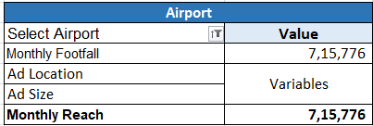

- Monthly Footfall
- Ad Location
- Ad Size
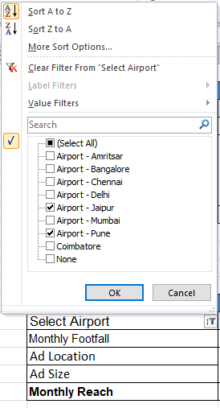
Select the location [s] from the filter option in the Airport table to get the estimated reach.
- Digital- Digital Advertising is one of the tremendously growing advertising medium. The two key factor which defines of the reach of any digital platform is the ad type and the pricing model (cpc, cpm, cpi, cpv)

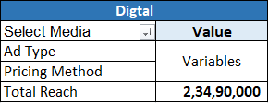

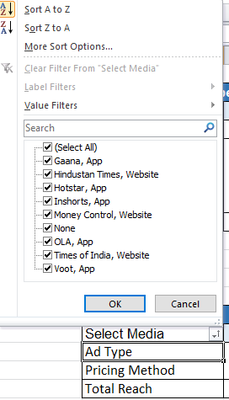

Select the platform [s] from the filter option in the Digital table and get the count of estimated reach of your chosen platforms.

Once you select all of your preferred filters, you’ll be able to count the individual reach or the combine reach of all of your selected mediums.
NOTE- This is the sneak peak of the main Reach Calculator tool, hence a few of the variables are kept unchangeable.
Contact us for a fully personalized reach calculator where you will be able to play with all the variables and optimize your marketing campaigns accordingly.
- The Outdoor and Television advertising medium are not available in the free version. Contact us at help@themediaant.com to get the access to the paid tool.
Your calculation is ready!! What next?
So you have successfully calculated the estimated reach of the various advertising options, here are the following next steps that you can follow-
- Make effective marketing strategies, you can also send us your plan and we will take care of your marketing campaigns from the scratch until you get the results.
- If you wish to get the fully dynamic tool in which you can manipulate each and every single variable to make more effective marketing strategies then contact is at help@themediaant.com

